# Homework #1: Testing Windows Server 2012 VM

## Submission Guideline

* This is an individual assignment and is worth 20 points. You may work in pairs, however, every student must produce and submit their on reports.
* The submission deadline is Tuesday, September 5 (by midnight).
* Use the “CIS 483 HW#1-Tasks.docx” file to provide your outcomes.
* Follow the naming convention: homework, underscore, and extension (e.g., Homework #1.docx).
* Do not use any of the sample screenshots provided as illustrations.
* Zoom in the screenshots so that the images are clearly readable. When the images are not readable, the grader can deduct 1 point for each screenshot.
* If you have any questions, feel free to reach out to me.

## Instructions

* Find your ID for the Proxmox Server from Blackboard under **Start Here/Class Roster for Proxmox Fall 2024**.

## Tasks

**(TASK 1: 5 points)** Login to the Windows Server and take a screenshot of the main screen.

* Launch SQL Server 2016 Configuration Manager by clicking on the icon for the manager on the bottom of the screen.



**(TASK 2: 5 points)** Show in a screenshot MS SQL Server services that are available like below.

* To be able to start **Microsoft SQL Server**, you have to start **SQL Server (MSSQLSERVER)** service on the Configuration Manager. Right click on the icon for the service and click on **Start**. The service is turned off by default to save the memory. Every time you log in to Windows Server and start SQL Server, you must start **SQL Server (MSSQLSERVER)** service manually.
* Click on **Microsoft SQL Server Management Studio 17** icon.



* After the SQL Server main screen is loaded, select **Windows Authentication** to log in as **Administrator**. Click on **Connect**.

**(TASK 3: 5 points)** Execute the following queries. Show the results in a screenshot. You must show that the installation is SQL Server 2016 Standard.

SELECT @@version

SELECT SERVERPROPERTY('productversion'), SERVERPROPERTY ('productlevel'), SERVERPROPERTY ('edition')

* To run a query, click on **New Query**.

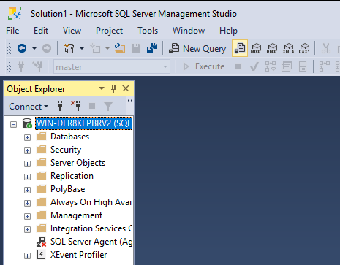

* Click on **Databases** on Object Explorer. Find the sample databases that are attached: AdventureWorks2016CTP3 and WideWorldImporters.

**(TASK 4: 5 points)** Execute the following query. 1) Show the result in a screenshot. 2) How many departments did you get with the query? You need to answer both questions explicitly.

Select * From [AdventureWorks2016CTP3].[HumanResources].[Department]

Go

16 departments

